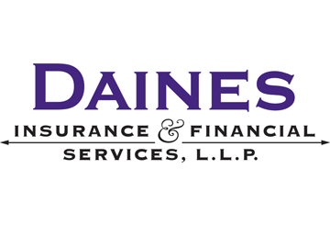
Are you compliant with all federal benefits laws, rules and regulations?
There are countless rules and regulations governing employee benefit plans, many of which are complex. Our resources will help you meet your compliance obligations and keep you up-to-date on laws and regulations that affect your employee benefits program.
Do you have access to constantly updated compliance bulletins and guides?
Our easy-to-read articles will help you find answers to your common COBRA, FMLA, health care reform, HIPAA, HIPAA Privacy, Medicare Part D and Section 125 questions.
Would you like community support?
Have a compliance-related question? Join an active community of knowledgeable colleagues from all over the country. Post your questions and share resources and information via your community’s interactive forum, available on your custom portal.
(903) 793-3034
www.dainesinsurance.com

Sample Documents
Table of Contents

Significant Changes Proposed to Form 5500 3
IRS Announces HSA/HDHP Limits for 2017 4
COBRA Continuation Coverage 5
HR Q&A: FMLA Notice Requirements 6
ERISA Compliance FAQs: Reporting and Disclosure Rules 7
DOL Audit Guide: Employee Benefit Plans 8
2017 Open Enrollment Checklist 10
Understanding the New Overtime Rules 11

Significant Changes Proposed to Form 5500

HIGHLIGHTS
The proposal would eliminate the current filing exemption for small group health plans.
Small group health plans that are fully insured would be required to provide only basic information.
The new Schedule J would report information about group health plan operations and compliance.

IMPORTANT DATES
January 1, 2019
The proposed changes to the Form 5500 would apply for plan years beginning on or after Jan. 1, 2019.
January 1, 2020
EFAST2 is expected to begin processing the 2019 Form 5500.

OVERVIEW
On July 21, 2016, a proposed rule was published by federal regulators that seeks to modernize and improve the Form 5500 annual return/report that is filed by employee benefit plans. In general, the changes are expected to apply for plan years beginning on or after Jan. 1, 2019.
While the Form 5500 is periodically updated so that it stays current with legal and market developments, these proposed updates are significant because of their focus on group health plans. Significantly, the proposed rule would eliminate the current filing exemption for small group health plans and require group health plans to complete a new detailed schedule.
In addition to these changes, the proposed changes would expand the Form 5500’s financial and compliance reporting, analytics capability and service provider information.

ACTION STEPS
Employers should monitor these proposed changes to the Form 5500 and consider how the changes would affect them if they are finalized. Employers with small group health plans that have been exempt from the Form 5500 filing requirement may wish to contact service providers to evaluate their options for Form 5500 filings.
Provided By:
Daines Insurance & Financial Services, LLP
This is a sample document provided by Daines Insurance & Financial Services, LLP
3

IRS Announces HSA/HDHP Limits for 2017

HIGHLIGHTS
Each year, the IRS announces inflation-adjusted limits for HSAs/HDHPs.
The adjusted contribution limits for HSAs take effect as of the next Jan. 1.
The adjusted HDHP limits (minimum deductible and maximum out-of-pocket expenses) take effect for the plan year beginning on or after the next Jan. 1.

IMPORTANT DATES
January 1, 2017
The new contribution limits for HSAs become effective. The only change for 2017 is the $50 increase to the contribution limit for individuals with self-only HDHP coverage.
2017 Plan Years
The HDHP cost-sharing limits for 2017 apply for plan years beginning on or after Jan. 1, 2017. These limits are the same as the 2016 limits.

OVERVIEW
On April 29, 2016, the Internal Revenue Service (IRS) released Revenue Procedure 2016-28 to announce the inflation-adjusted limits for health savings accounts (HSAs) and high deductible health plans (HDHPs) for 2017. These limits include:
- The maximum HSA contribution limit;
- The minimum deductible amount for HDHPs; and
- The maximum out-of-pocket expense limit for HDHPs.
These limits vary based on whether an individual has self-only or family coverage under an HDHP.
The minimum deductible and maximum out-of-pocket limits for HDHPs will not change for 2017 plan years. The only limit that will change for 2017 is the HSA contribution limit for individuals with self-only coverage under an HDHP, which will go up by $50.

ACTION STEPS
Because the limits for HDHPs will not change for 2017, employers that sponsor these plans will not need to make plan design changes to comply with the IRS’ rules for HDHP minimum deductibles and maximum out-of-pocket limits.
Provided By:
Daines Insurance & Financial Services, LLP

This is a sample document provided by Daines Insurance & Financial Services, LLP
4

Provided by Daines Insurance & Financial Services, LLP

COBRA Continuation Coverage

COBRA BASICS
- COBRA allows certain employees, spouses and dependents to temporarily continue their health coverage at group rates.
- COBRA coverage must be the same as the coverage that is available to similarly situated active employees who are not receiving COBRA benefits.
COMPLIANCE TIPS

Avoid common compliance mistakes by:
- Determining if COBRA applies to your health plan;
- Knowing which events trigger the requirement to offer COBRA coverage;
- Providing the required COBRA notices on a timely basis; and
- Establishing payment procedures for COBRA premiums.
The Consolidated Omnibus Budget Reconciliation Act (COBRA) allows individuals to continue their group health plan coverage in certain situations. Specifically, COBRA requires group health plans to offer continuation coverage to covered employees and dependents when coverage would otherwise be lost due to certain specific events.
These events include the death of a covered employee, termination or a reduction in the hours of a covered employee's employment, divorce of a covered employee and spouse, and a child's loss of dependent status under the plan.
COBRA sets rules for how and when continuation coverage must be offered and provided, how employees and their families may elect continuation coverage and when continuation coverage may be terminated.
Employers may require individuals to pay for COBRA coverage. Group health coverage for COBRA participants is usually more expensive than coverage for active employees, since many employers pay a part of the premium for active employees.
Links And Resources
- The Department of Labor’s (DOL) COBRA continuation coverage Web page.
- An Employer’s Guide to Group Health Continuation Coverage Under COBRA – DOL resource
- The DOL’s model COBRA forms – Model General Notice and Model Election Notice

This is a sample document provided by Daines Insurance & Financial Services, LLP
5

Courtesy of Daines Insurance & Financial Services, LLP

What notices must employers provide to employees regarding the FMLA?

Employers must provide employees with the following notices regarding the FMLA: General Notice, Eligibility Notice, Rights and Responsibilities Notice, and a Designation Notice. The notices are explained briefly in the following paragraphs.
General Notice
Employers covered by the FMLA must prominently post a general FMLA notice where it can be readily seen by employees and applicants for employment. The general notice explains an employee’s rights and responsibilities under the FMLA. The Department of Labor (DOL) has developed a model general notice for employers to use.
Covered employers must post this general notice even if no employees are eligible for FMLA leave. Covered employers that have any eligible employees must provide this notice to each employee by including it in any written guidance to employees or distributing a copy of the general notice to each new employee upon hiring.
Eligibility Notice
When an employee requests FMLA leave, or when the employer learns that an employee’s leave may be for an FMLA-qualifying reason, the employer must notify the employee of his or her eligibility to take FMLA leave within five business days, absent extenuating circumstances. The DOL has provided a sample eligibility notice for employers to use.
Rights and Responsibilities Notice
Each time the eligibility notice is provided, employers must provide a written notice detailing the specific expectations and obligations of the employee and explaining any consequences of a failure to meet these obligations. The DOL has provided a sample rights and responsibilities notice for employers to use. This notice is often combined with the eligibility notice.
If the information provided by the rights and responsibilities notice changes, the employer must notify the employee of the change.

This is a sample document provided by Daines Insurance & Financial Services, LLP
6
Provided by Daines Insurance & Financial Services, LLP

ERISA Compliance FAQs: Reporting and Disclosure Rules
PLAN DOCUMENT/SPD

Employee benefits that are subject to ERISA must be described in a plan document and SPD.

For welfare benefits, one document often serves as both the plan document and the SPD.

When a plan is insured, a “wrap document” may be used to describe plan benefits.
FORM 5500

ERISA-covered employee benefit plans must file a Form 5500 each year, unless an exemption applies.

Small welfare plans that are unfunded or insured are exempt.

To qualify for the small plan exemption, the plan must have fewer than 100 covered participants at the beginning of the plan year.

The Employee Retirement Income Security Act of 1974 (ERISA) is a federal law that sets minimum standards for employee benefit plans maintained by private-sector employers. ERISA includes requirements for both retirement plans (for example, 401(k) plans) and welfare benefit plans (for example, group health plans). ERISA has been amended many times over the years, expanding the protections available to welfare benefit plan participants and beneficiaries.
The Department of Labor (DOL), through its Employee Benefits Security Administration (EBSA), enforces most of ERISA’s provisions. Violating ERISA can have serious and costly consequences for employers that sponsor welfare benefit plans, either through DOL enforcement actions and penalty assessments or through participant lawsuits.
This Compliance Overview includes a set of frequently asked questions (FAQs) to help employers understand ERISA’s requirements for reporting and disclosure.
Links And Resources
- The DOL’s Reporting and Disclosure Guide for Employee Benefit Plans.
- Form 5500 Series website, which includes links to the Form 5500 and instructions.
- Fact sheet on the Delinquent Filer Voluntary Correction Program

This is a sample document provided by Daines Insurance & Financial Services, LLP
7

Presented by Daines Insurance & Financial Services, LLP

This is a sample document provided by Daines Insurance & Financial Services, LLP
8

PREPARING FOR (AND AVOIDING) A DOL AUDIT

Because a DOL audit can disrupt an employer’s day-to-day business operations and possibly result in penalties (or other corrective action), it is important for employers to know how to prepare for, and potentially avoid, a DOL audit of their health plan.
As a general rule, the best way to prepare for a DOL audit of your health plan is to confirm that your plan complies with all applicable federal laws, such as HIPAA and the ACA. It is also important to have documents showing your compliance and to maintain these documents so they are easy to access in the event of a DOL audit. If an employer takes these steps before being selected for audit, it can reduce its exposure to penalties. It can also make the audit process more manageable and less time-consuming.
It is also important for an employer to understand why the DOL selects certain health plans for audit and take steps to minimize that audit risk.

AUDIT TRIGGERS
A DOL audit can be triggered for a variety of reasons. In most cases, the DOL investigator will not disclose to an employer why its health plan was selected for audit. However, there are some common audit triggers that an employer should keep in mind.
Common triggers for a DOL audit include:
- Participant complaints to the DOL about potential ERISA violations. In 2013, according to a DOL audit summary, 775 new investigations were opened as a result of participant complaints.
- Answers on the plan’s Form 5500. For example, if a plan’s Form 5500 is incomplete, or if inconsistent information is reported from year to year, the DOL may investigate the issue further.
- The DOL’s national enforcement priorities or projects, which target the DOL’s resources on certain issues. For example, the DOL’s Health Benefits Security Project focuses on making sure health plans and health insurance issuers comply with the ACA’s mandates.
This is a sample document provided by Daines Insurance & Financial Services, LLP
9
Provided by Daines Insurance & Financial Services, LLP

2017 Open Enrollment Checklist
To prepare for open enrollment, group health plan sponsors should be aware of the legal changes affecting the design and administration of their plans for plan years beginning on or after Jan. 1, 2017. Employers should review their plan documents to confirm that they include these required changes.
In addition, any changes to a health plan’s benefits for the 2017 plan year should be communicated to plan participants through an updated summary plan description (SPD) or a summary of material modifications (SMM).
Health plan sponsors should also confirm that their open enrollment materials contain certain required participant notices, when applicable—for example, the summary of benefits and coverage (SBC). There are also some participant notices that must be provided annually or upon initial enrollment. To minimize cost and streamline administration, employers should consider including these notices in their open enrollment materials.
PLAN DESIGN ISSUES
- Confirm your plan’s out-of-pocket maximum complies with the ACA’s limits for 2017.
- For HDHPs, confirm that the plan’s deductible and out-of-pocket maximum comply with the 2017 limits.
- For wellness programs that include HRAs, review compliance with the new EEOC rules.
NOTICES TO INCLUDE
- Annual CHIP notice
- Medicare Part D creditable coverage notice
- Notice of grandfathered status (if applicable)
- Annual notice regarding coverage requirements for mastectomy related benefits (WHCRA notice)

Links And Resources
- Revenue Procedure 2016-28, which includes the inflation-adjusted limits for HSAs and HDHPs for 2017
- Revised SBC template, instructions and Uniform Glossary (for use on or after April 1, 2017)
- EEOC’s new rules for wellness programs under the ADA and GINA
This is a sample document provided by Daines Insurance & Financial Services, LLP
10

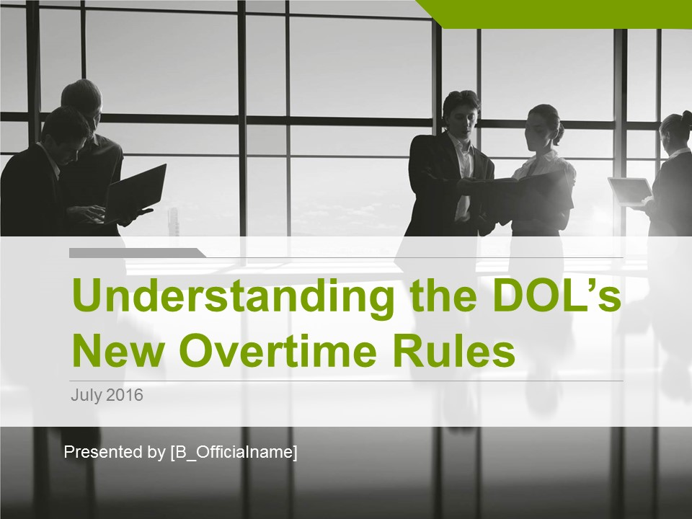
This is a sample document provided by Daines Insurance & Financial Services, LLP
11
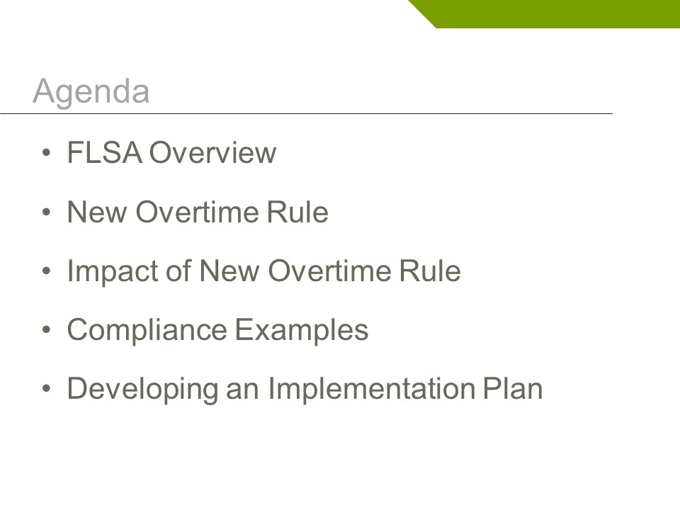
This is a sample document provided by Daines Insurance & Financial Services, LLP
12

